Screenshots
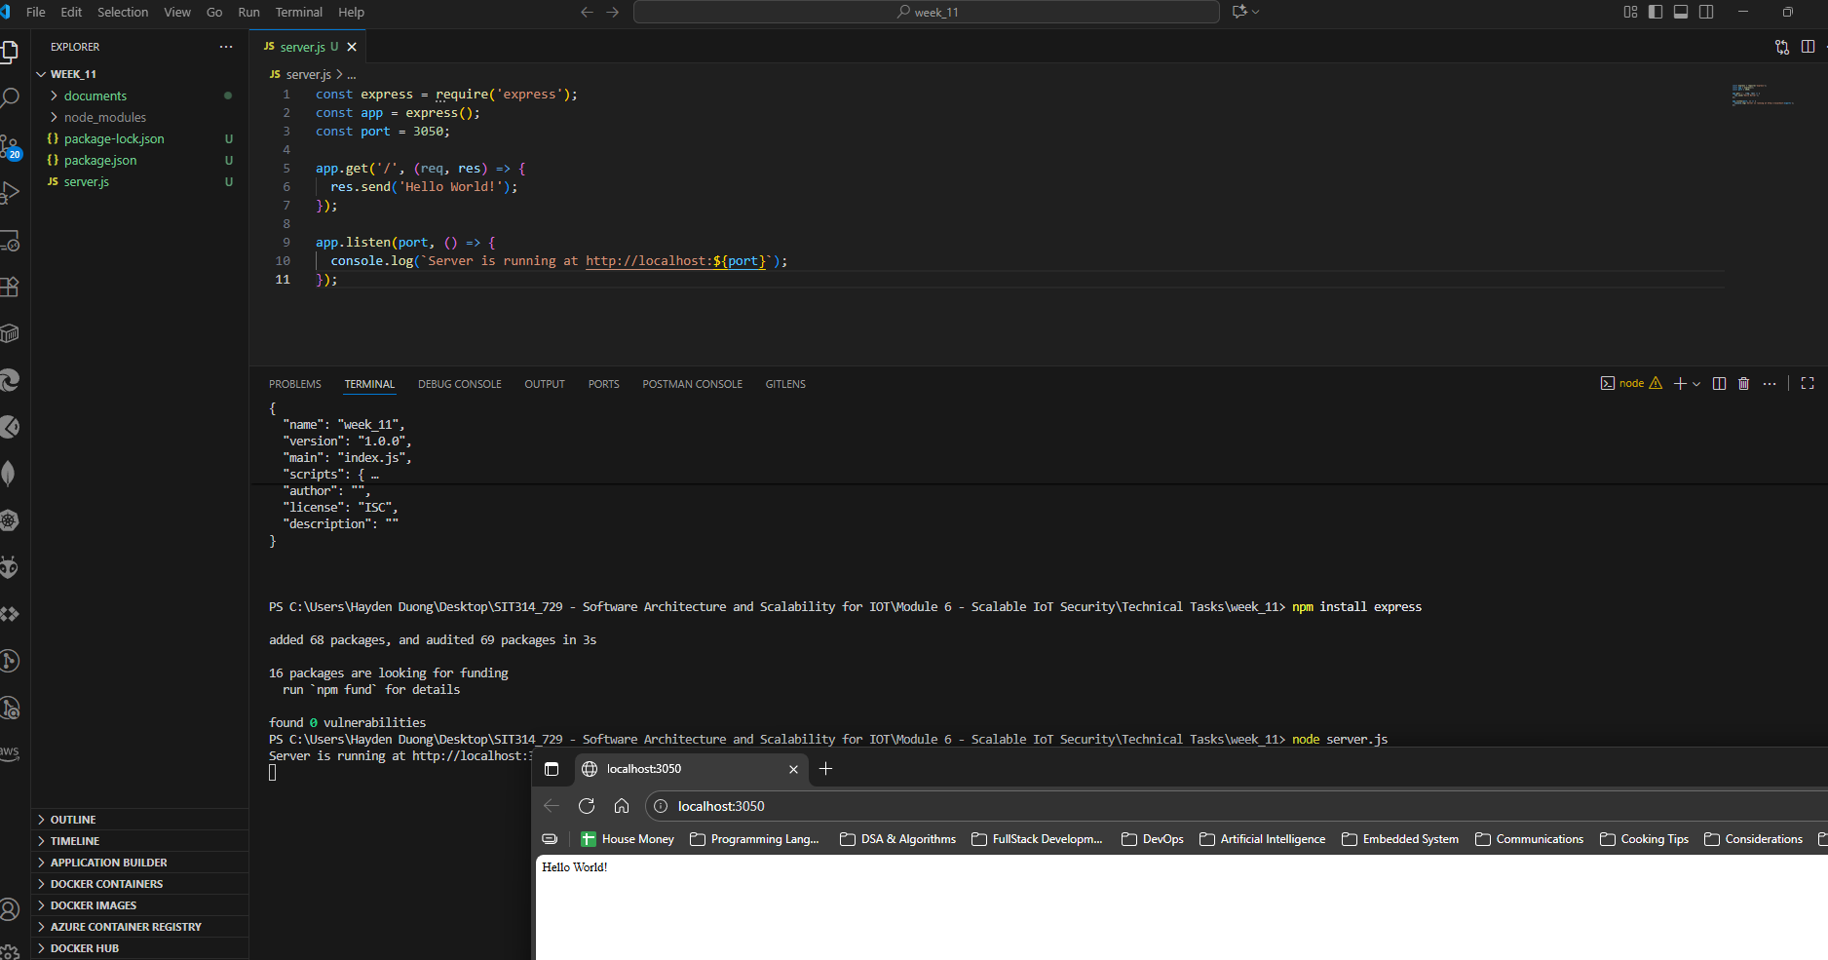
Picture 1 – Successfully accessed to http://localhost:3050.

Used WSL – Ubuntu method for Window 11 to generate the SSL Certificate
- PEM pass phrase: vietnam
- Country Name: AU
- State or Providence Name: Victoria
- Locality Name: Burwood East
- Organization Name: Deakin University
- Organization Unit: SEBE
- Common Name: Hayes
- Email Address: none
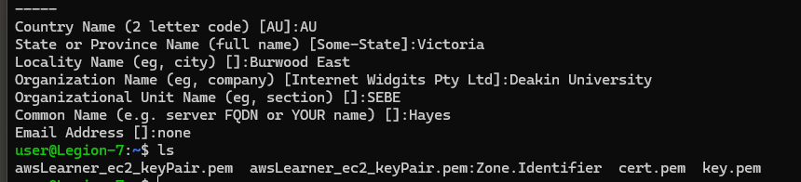
Picture 2 – Generated cert.pem & key.pem.
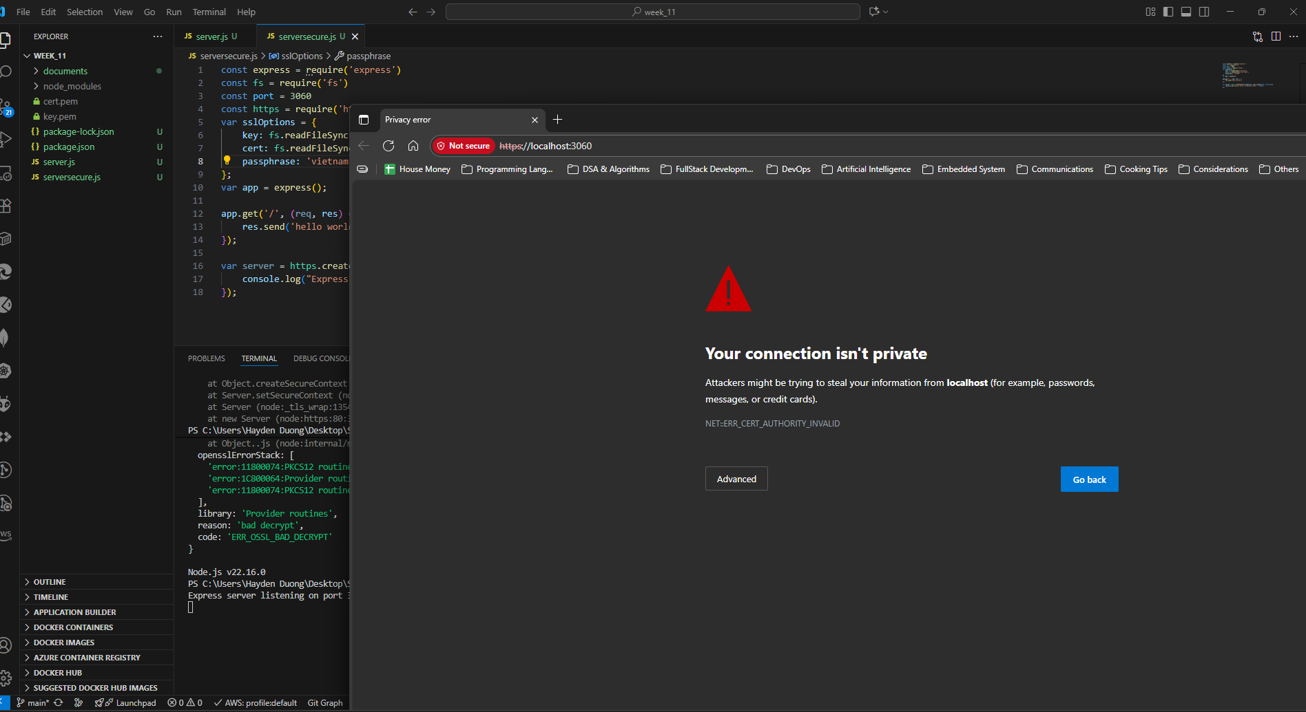
Picture 3 – Able to access the URL, however, “connection isn’t private” error occurred.

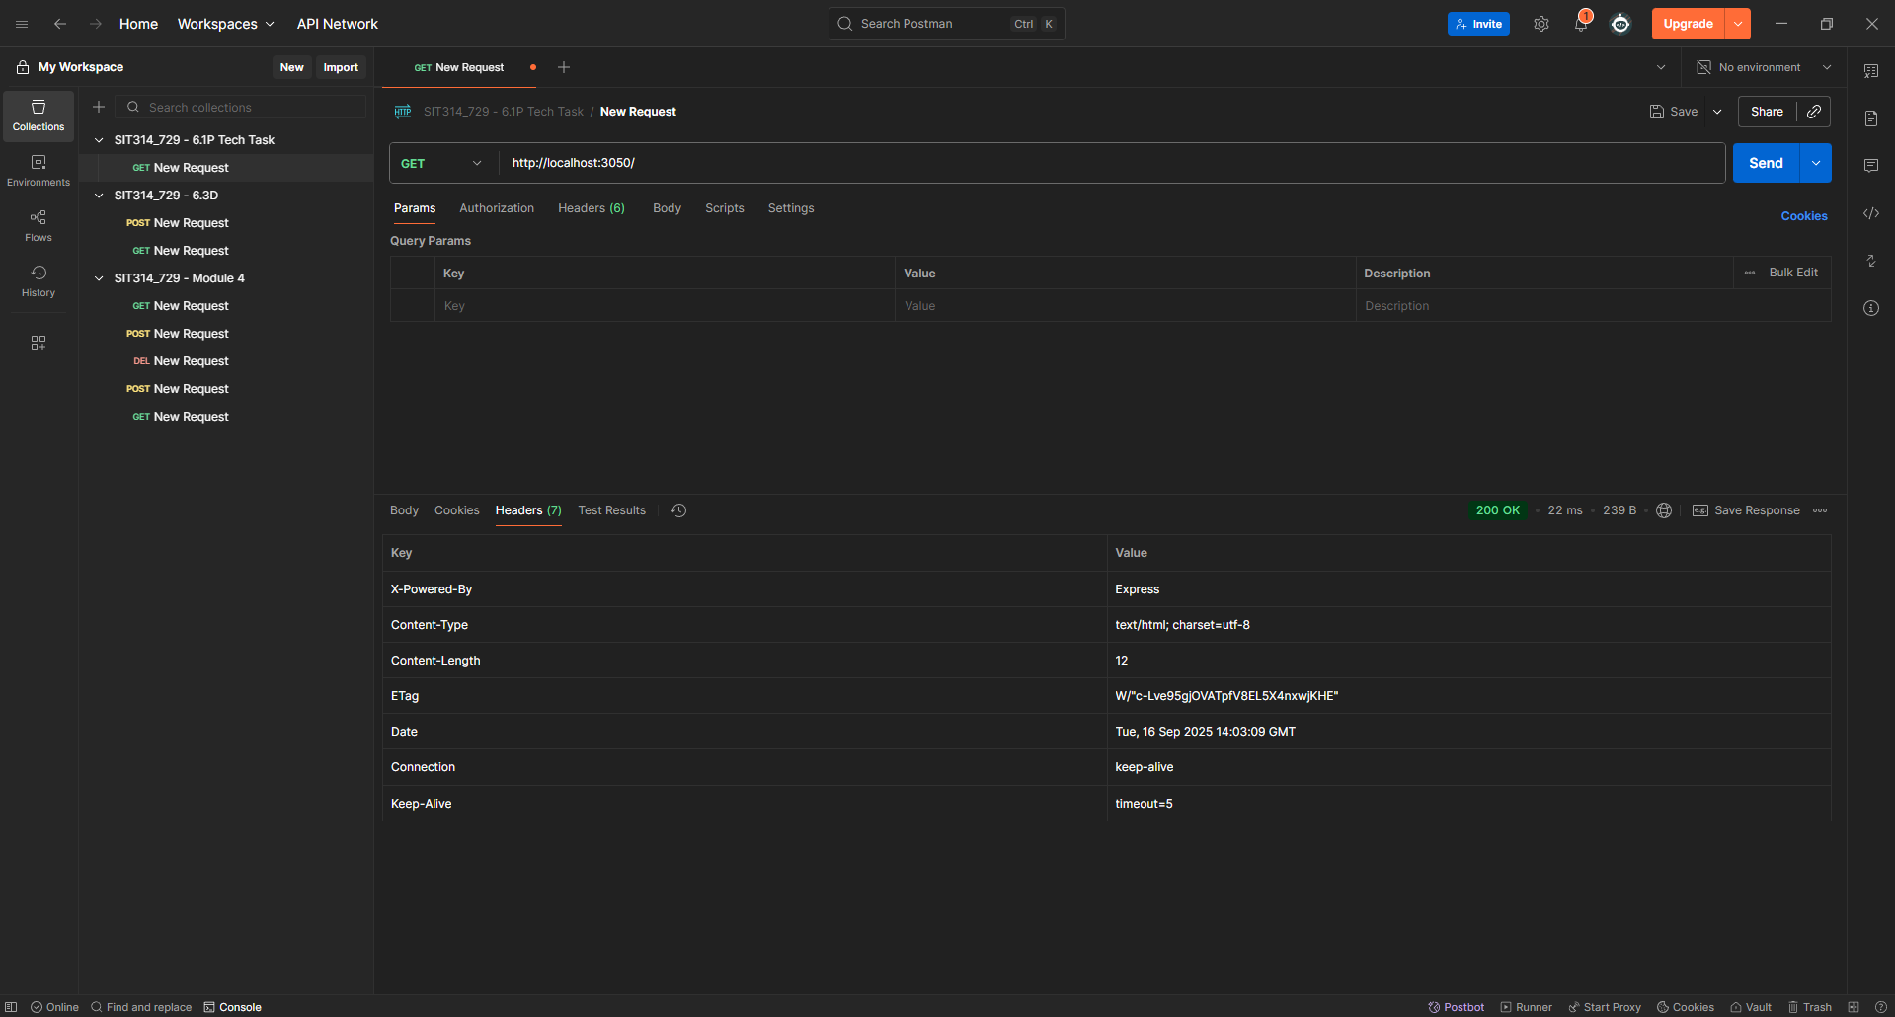
Picture 4 – Tested server.js with Postman.
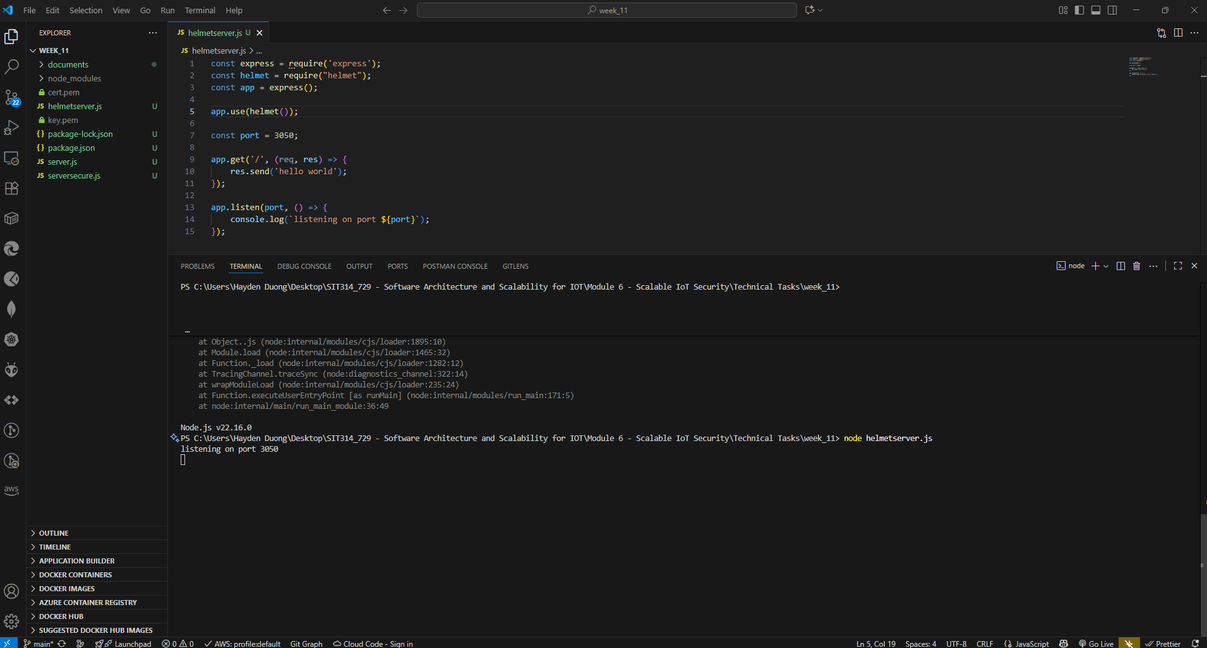
Picture 5 – Able to run the “helmetserver.js”

- It was found that the suggested code-lines related to “helmet” middleware is a deprecated version and no longer supported.
- “app.use(helmet());” is sufficient.

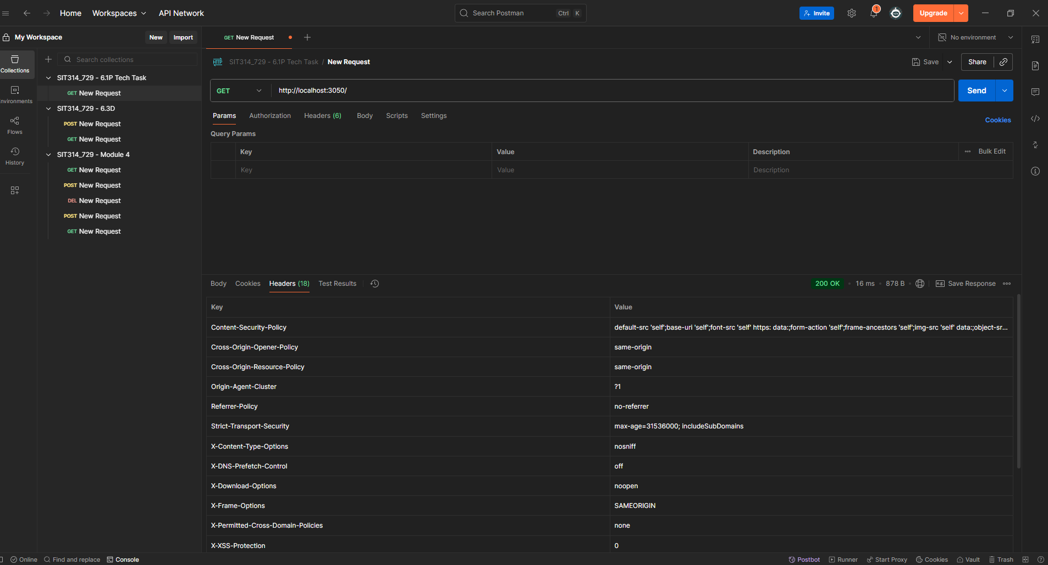
Picture 6 – Results obtained from testing “helmetserver.js” via Postman.

Explanation from the results obtained from both “server.js” and "helmetserver.js”:
Understanding the Role of Helmet.js in Web Security
The two API network screenshots demonstrate a clear difference in the HTTP headers returned by a standard Express server versus one using the Helmet.js middleware. This difference highlights Helmet's primary function: to enhance web application security by setting a variety of HTTP headers.
By default, a basic Express server only provides a minimal set of headers, such as X-Powered-By, Content-Type, and Content-Length. These headers provide very little protection against common web vulnerabilities.
When the helmet() middleware is added to the server, it automatically adds or modifies a range of security-focused headers. Each of these headers serves a specific purpose in defending the application and its users. For example:
- Content-Security-Policy: Prevents Cross-Site Scripting (XSS) and other injection attacks by specifying which sources of content (scripts, stylesheets, etc.) the browser is allowed to load.
- X-Frame-Options: Mitigates clickjacking attacks by preventing the website from being embedded within an <iframe> on another site.
- Strict-Transport-Security (HSTS): Forces the browser to connect to the server using HTTPS, which helps prevent Man-in-the-Middle (MITM) attacks by ensuring all communication is encrypted.
- X-Content-Type-Options: Protects against MIME-sniffing attacks by ensuring browsers adhere to the declared content type.
In summary, the presence of numerous security headers in the helmetserver.js response, and their absence in the server.js response, serves as direct evidence that Helmet.js successfully provides an essential layer of defense against several key web security threats. It is a best practice for modern web development to employ such security-focused headers to protect both the server and its users.

